How to run ansible on azure

This assumes a fresh server

1. Create an azure app registration

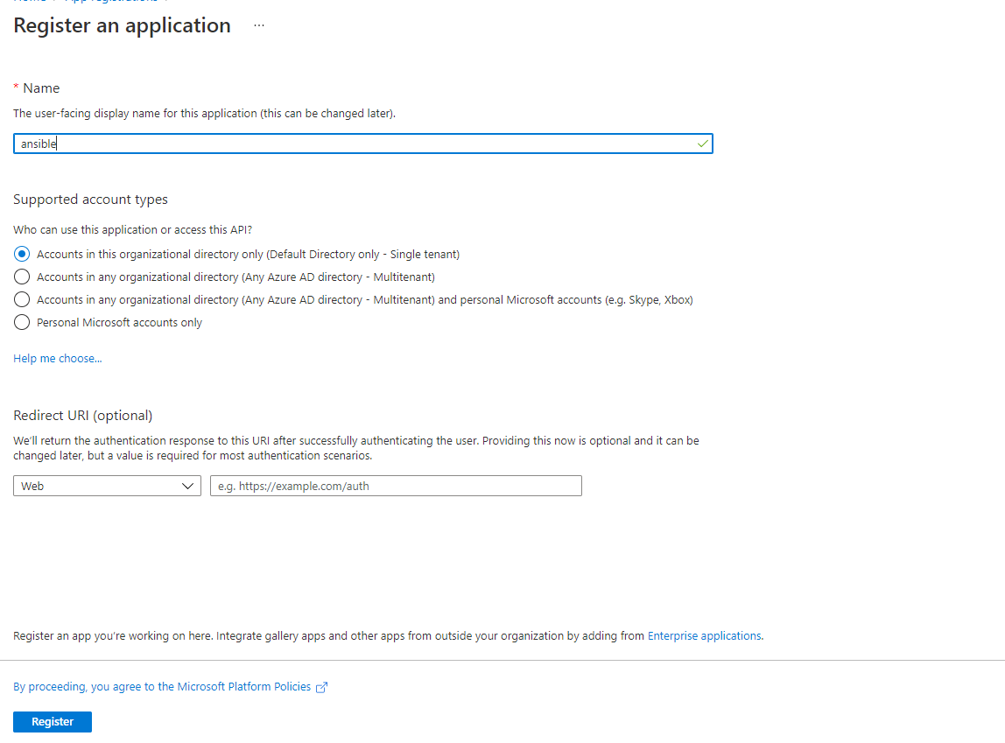

1. Get the needed IDs from the app registration

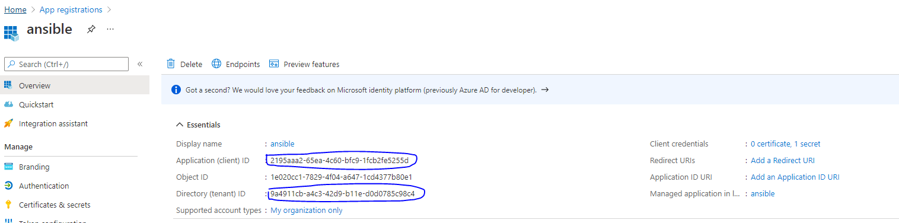

1. Create a secret for the app registration and copy the values

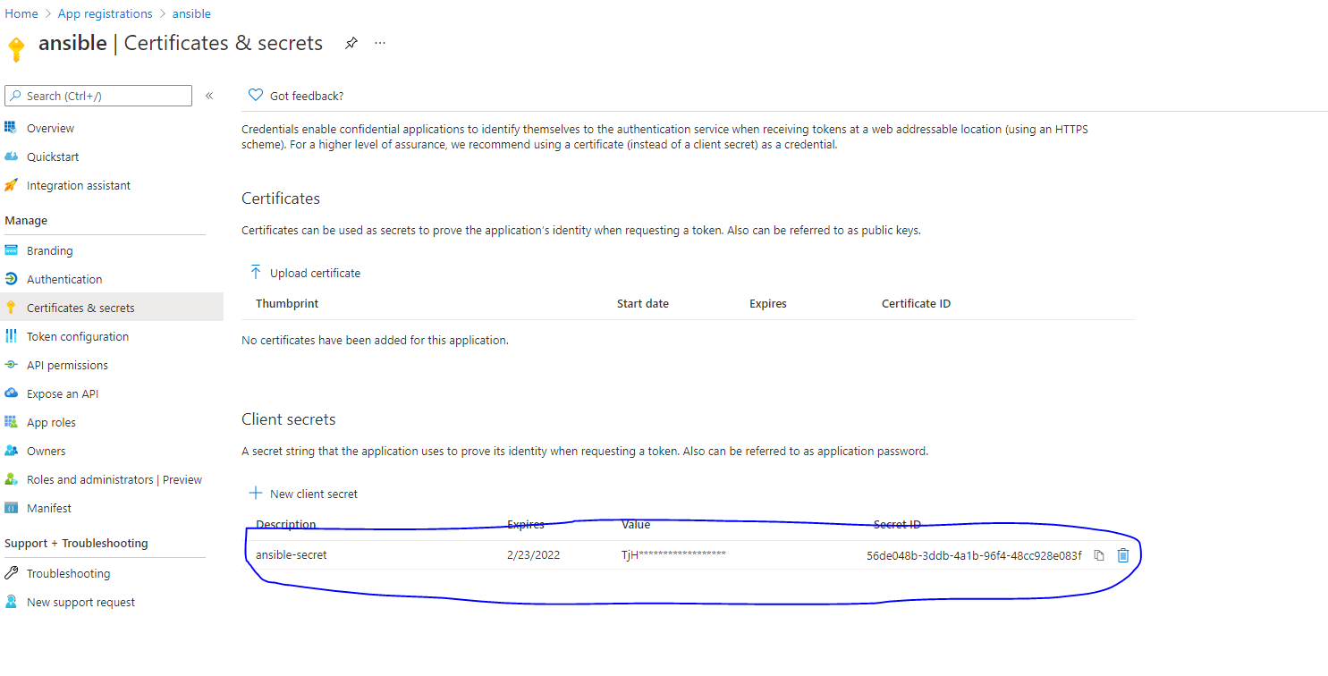

1. Get the subscription ID for azure



1. Assign the needed permissions for the service principle (app registration)

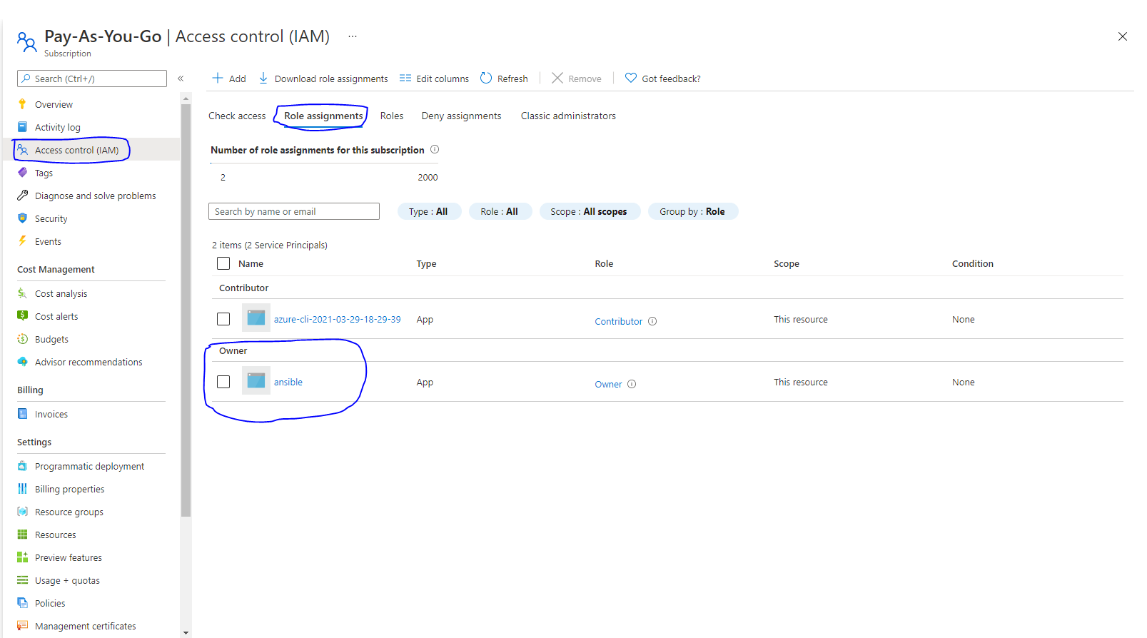

1. Install the epel-release repo



1. Install pip



1. Install ansible & azure modules (may need sudo)









1. Make a directory named .azure under your home dir



1. Make a file named credentials (you can also use ENV variables) to store azure creds inside the .azure directory



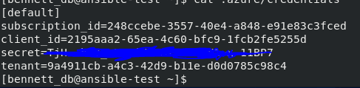

1. Create the playbook (anywhere is ok)

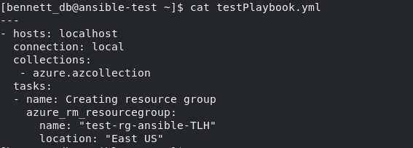

1. Run the play book

